<https://maine.egrantsmanagement.com>

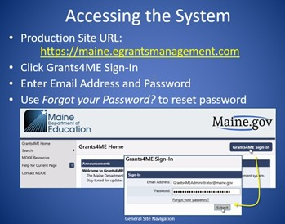

Click on the organization you are associated with.

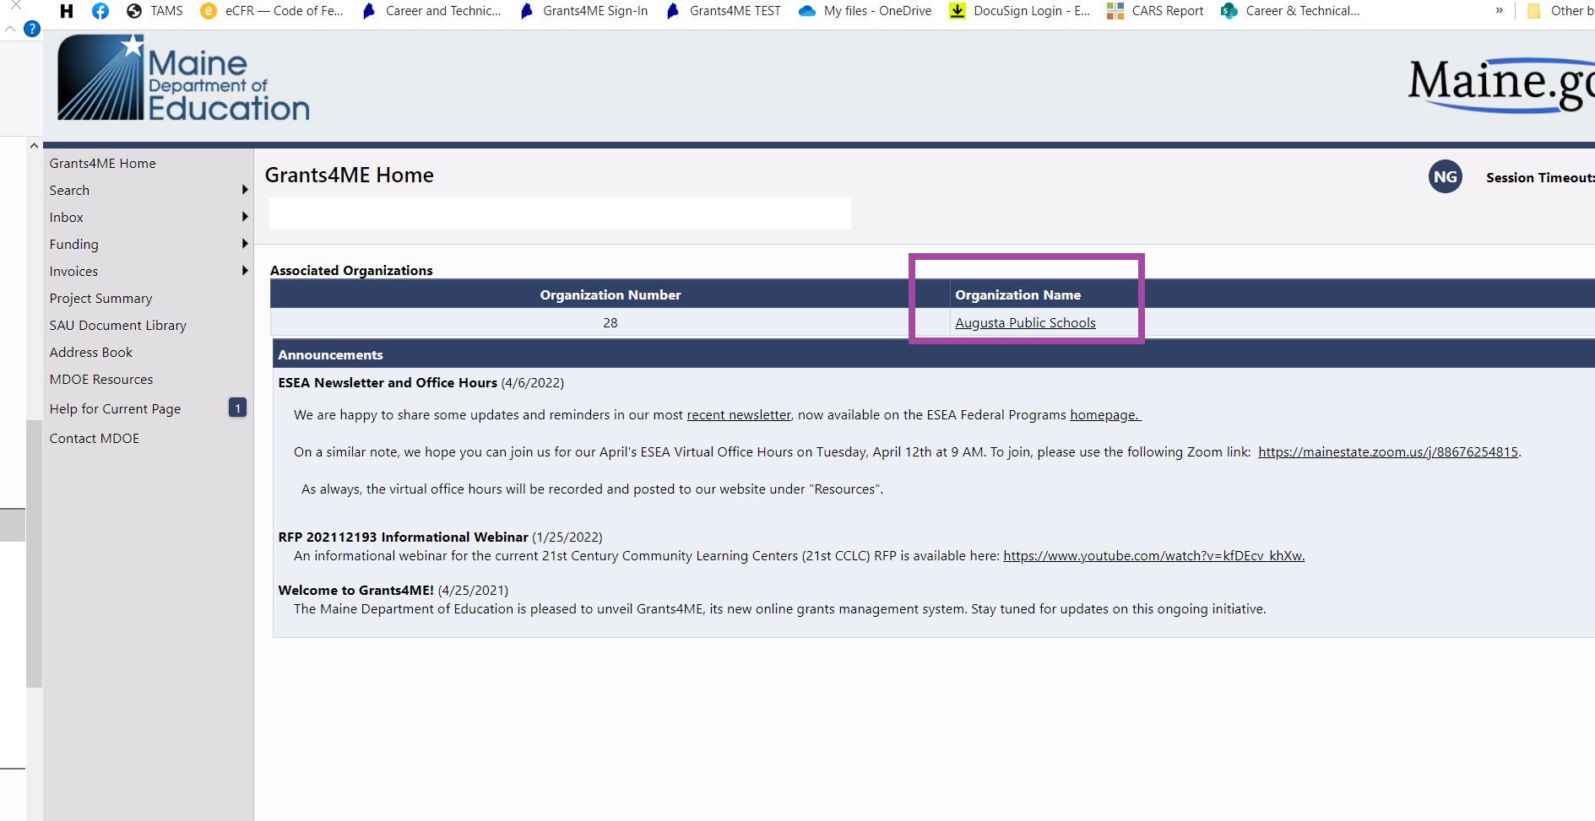

Choose 2023 from the dropdown.

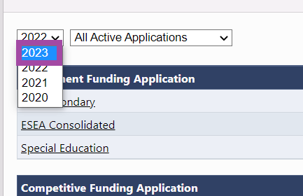

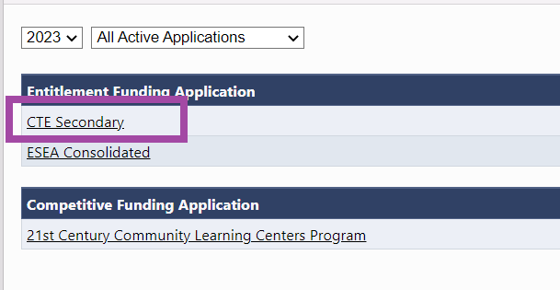Choose CTE Secondary.

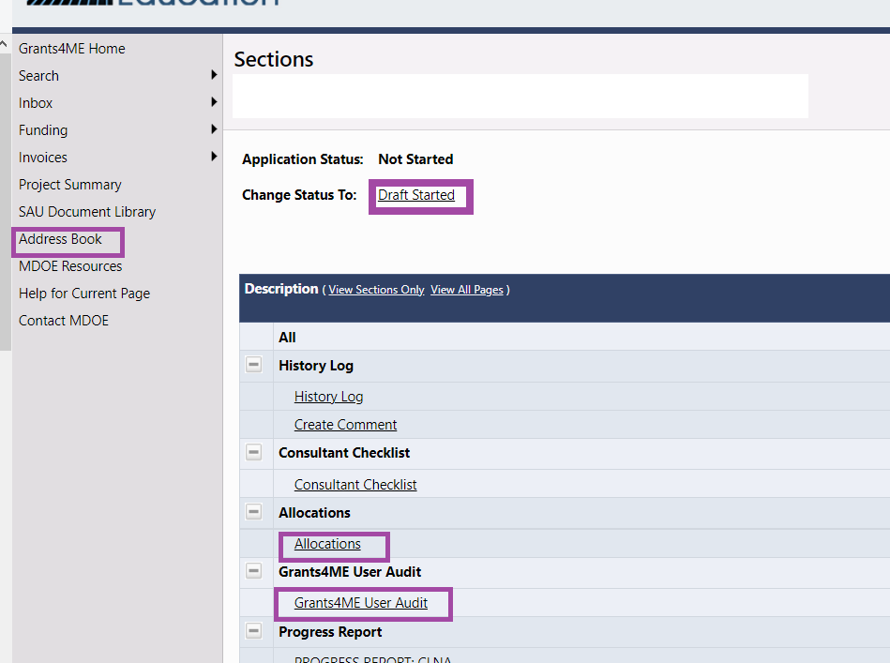

Status must be changed to Draft Started before input is activated.

You can view the list of Users for your organization by clicking on Address Book.

User audit requires you to acknowledge your User list is accurate.

Allocations will show you your award amount.

**NOTES:**

* **Be sure to use the Save and Go To button and not the back button of your browser.**
* **Sessions time out after 60 minutes on the same page. To reset the timer click the Save and Go To button.**
* **Entered information is NOT saved until you click Save and Go To button.**
* **To get back to the home screen click the Save and Go to button and select Sections.**
* **The CTE Director is the only user that can move the application to Draft Started and Draft completed. Grant writers cannot enter information until the application is moved to Draft Started by the CTE Director.**
* **The Progress Reports for FY22 are part of the FY23 application.**
* **For some sections there is an option to pull information forward from your FY22 Application. Be sure to review and update based on your FY23 CLNA.**
* **Funded activities continue to be entered in the budget section.**
* **All funded activities must align with your CLNA, including any FY23 updates and/or revisions.**
* **The budget must use the correct object and function codes. Please check with your District Business Manager if you are unsure what function or object codes to use.**
* **Be sure to verify whether a budget item is equipment, minor equipment, or supplies.**

This section is for the FY22 year-end narrative reports. The FY22 Final Expenditure Report is done within the FY22 Application and is completed by the Fiscal Representative with the Director approving once they complete.

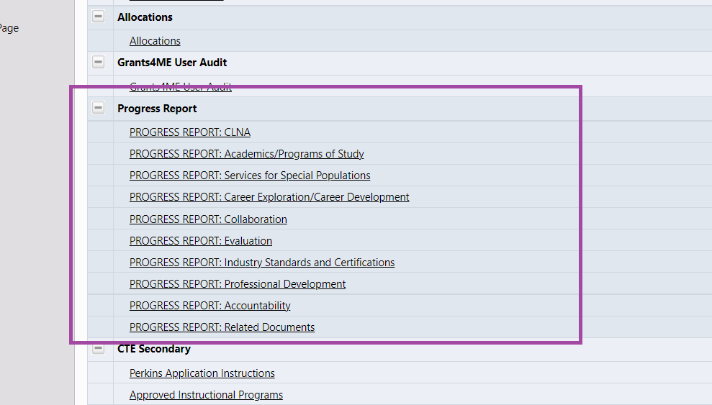

This section is your FY23 Perkins Application.

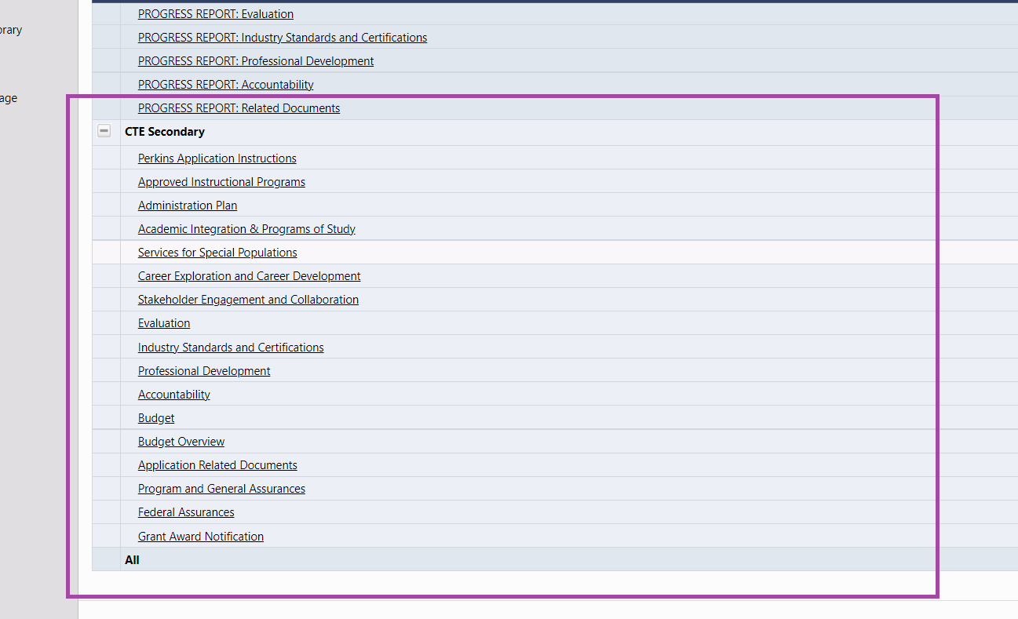

With the exclusion of your Approved Instructional Programs, Accountability, Budget, and Assurances sections, you may copy forward your FY22 Application narrative using the Copy Previous Fiscal Year Details link at the top of each section page.

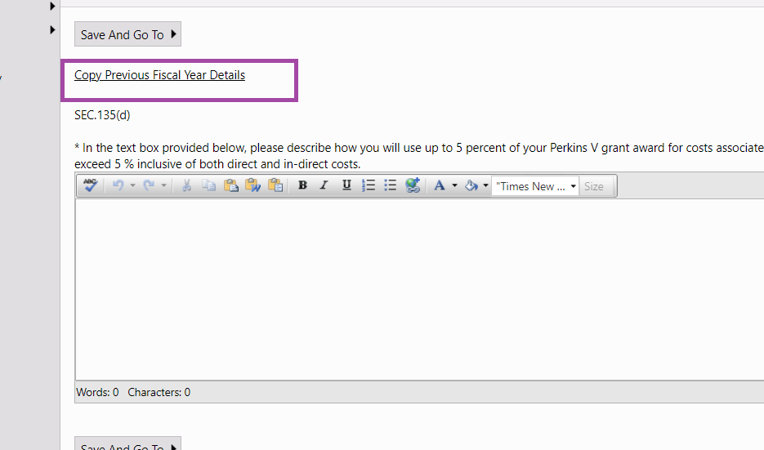

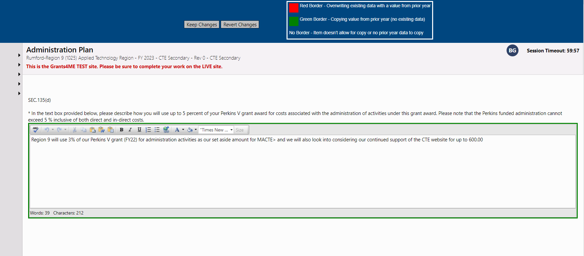

If you want to keep the text from last year you will click on Keep Changes. If you want to start fresh and go back to the blank text box click Revert Changes.

If you type in an answer and then decide you want to change to last year’s wording you click on Copy Previous Fiscal Year Details.

The red around the box shows you are going to delete the new wording and enter last year’s wording.

At any point you can decide to copy last year’s wording into the text box, but once you do that and Keep Changes… you cannot go back to previous wording you typed in the text box this year.

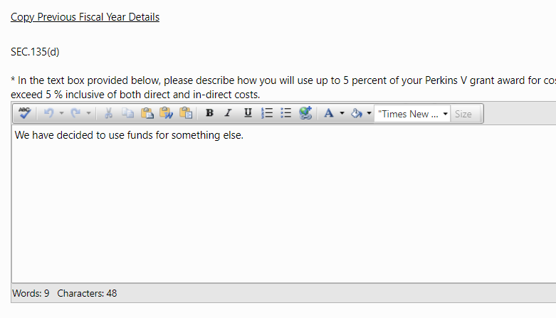 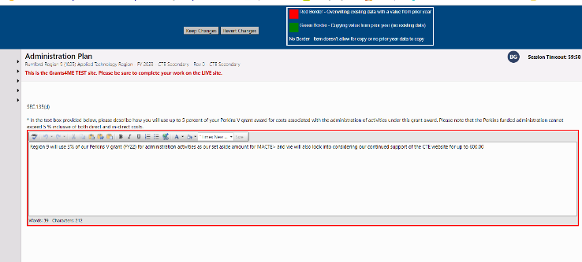

As you can see there is no border around the box now. I cannot go back to “We have decided to use funds for something else. You can delete the wording and enter the text again.

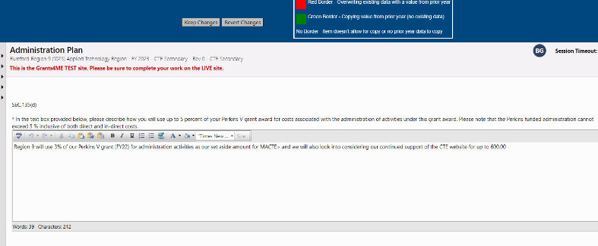

Budget pages can be listed by Function or Object. It opens to listing by Function. Click Budget by Object to change.

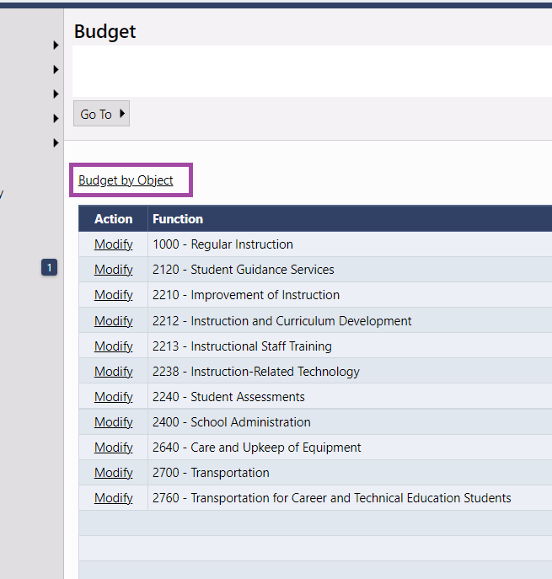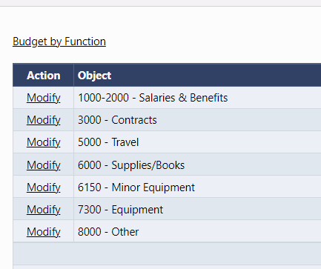

Click on Modify next to any Function or Object to add a budget activity. To see all of your activities click on Object (or Function) and <Select All>.

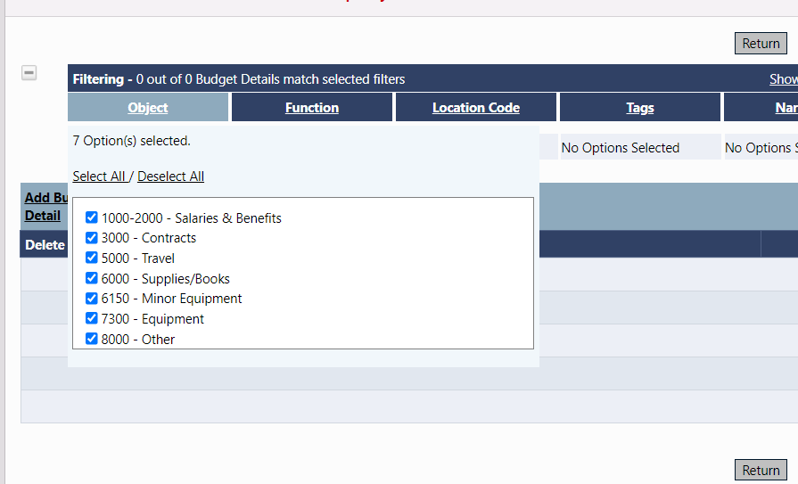

Click on Add Budget Detail to add an activity.

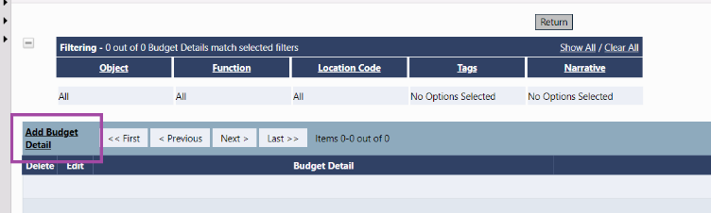

Fill out the budget detail just like you did last year. Be sure to select an Approved Instructional Program Tag and an Activity Tag. (Remember if your activity will be used for more than one program then select 99.9001 HMB Non-Counted CIP as your program tag.)

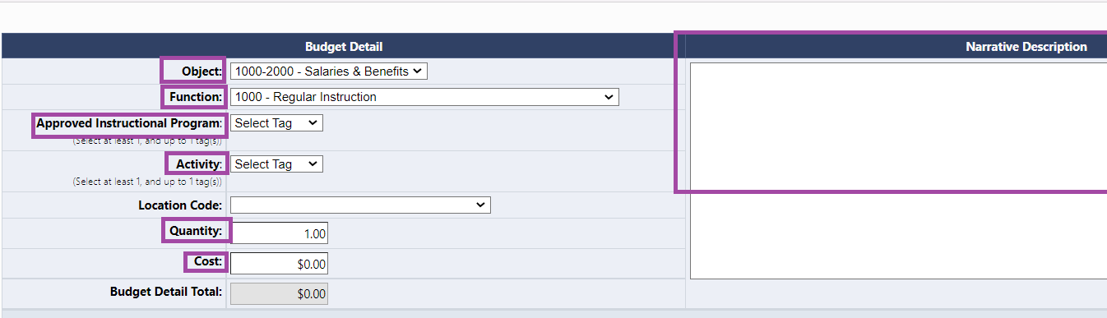

Note - ALL possible programs are listed in the drop down. If you choose a program that is not in your school's Approved Program List then you will receive a validation error. You can only purchase items for DOE approved programs. There will be a generic CIP to choose when paying for an activity that is not directly related to one program.

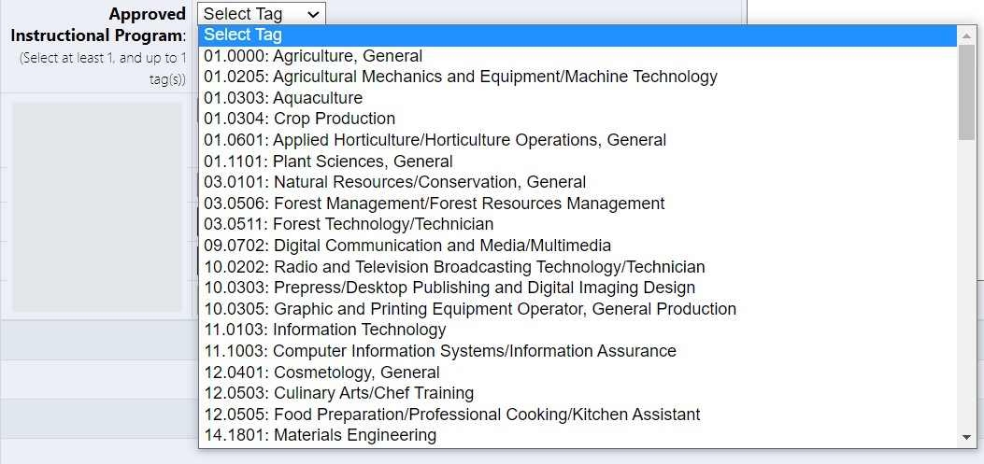

Note - the activity should align to a section of the application. This is the same process you completed in GEM, but the application section is a tag instead of within the grant application.

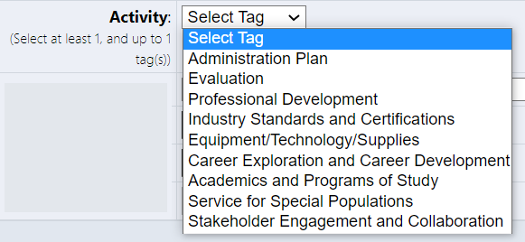

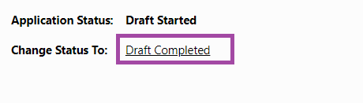  
Once you have completed the Progress Reports and Application the Director must change the status to Draft Completed to move the approval process forward. It then goes to the Fiscal Representative and finally to the Authorized Representative (Superintendent for Centers) for approval before it is fully submitted to MDOE for review. (Note… if you are a Region you may need to approve all 3, BUT if you have a business manager you should have them as your fiscal representative for stronger internal controls.

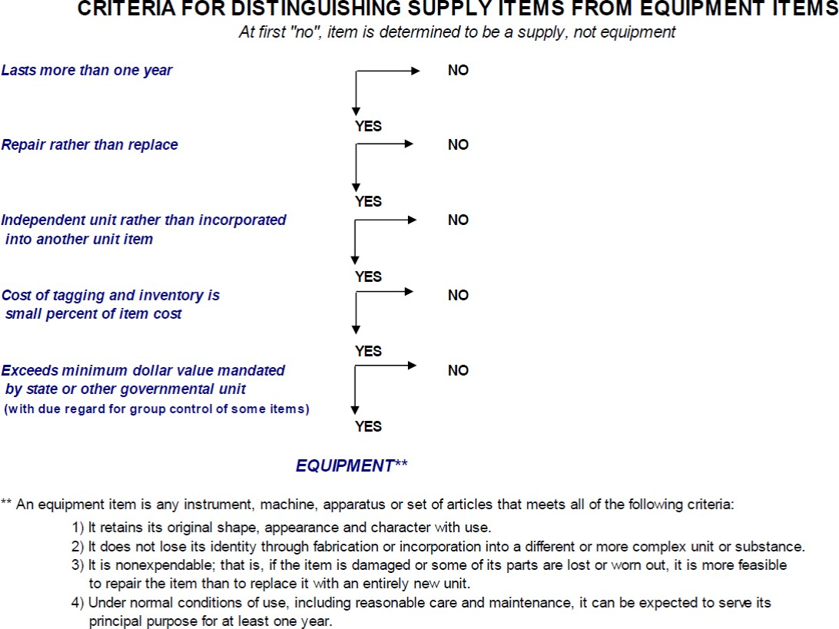

 .

Note

* **Object code 6150 is used for items costing less than $5,000, but are considered "walkable" and must be tracked in inventory. These items do not need to be tagged.**
* **Object code 7300 is used for equipment costing $5,000 or more. These items must follow Federal guidance 300.313. This requires items to be tagged and inventoried in detail.**
* **Object code 8000 should only be used for dues and memberships.**
* **Object code 5000 should be used for travel and student transportation.**
* **Object code 3000 should be used for contractual services and professional development registration fees.**
* **Function Codes 2210, 2212, 2213, and 2238 are aligned to Professional Development.**