Upgrades and changes in Staff

SAU Search functionality:
- A new column named “Position Status” added to the grid to display the collective status of the staff member.
  - If all the positions for a staff member are “Active” then the “Positions Status” shall be displayed as Active.
  - If at least one of the positions for a staff member is “In Progress” then the “Position Status” shall display InProgress with total number of positions in progress listed in parentheses.
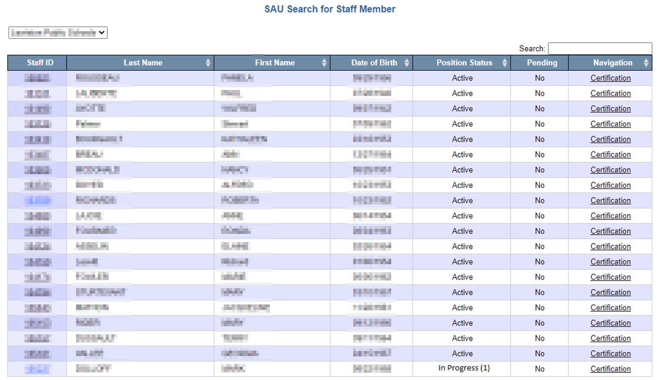

Staff Member Details:
- In Progress status added to the list of Assignment Status.
  - Selection of In Progress from the dropdown shall display the number of in progress positions (if any) only.
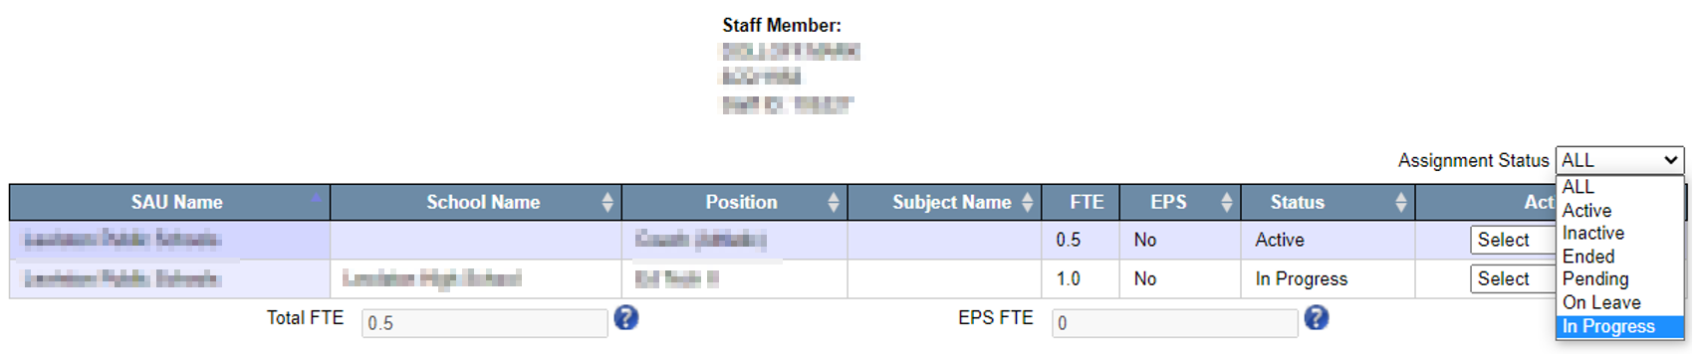
- All the “Active” position status shall be changed to In Progress position status when the End of Year job is run.
- All other logic in the staff details grid remains unchanged.

Staff Member Assignment:
- Save button added to the edit assignment screen, which can be accessed by selecting “Edit” from the dropdown for actions for each position.
  - If the user clicks on “Save” button, system shall save any edits made to assignment without any validations in the backend.
  - For any position, if the status was “Active” and the user edits and saves the assignment with any information, then the new status of “In Progress” shall be displayed.
  - For any position, if the status was “In Progress” and the user edits and saves the assignment with any information, then the status of “In Progress” shall be displayed.
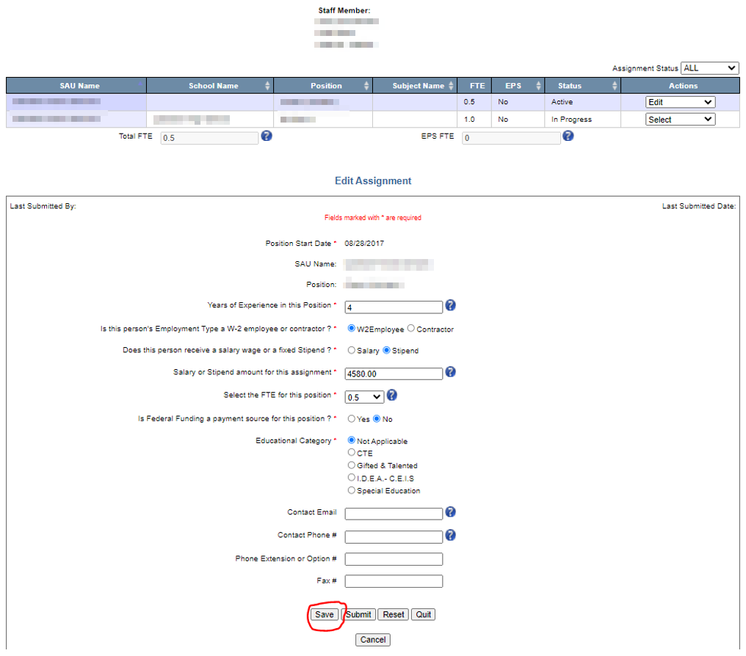
- Last Updated By and Last Updated Date is replaced by Last Submitted By and Last Submitted Date.
  - The two new fields of Last Submitted By and Last Submitted Date shall be blank for all the districts until the data in the new year is submitted.
  - System shall display the name of the user and the time stamp when the assignment changes were submitted.
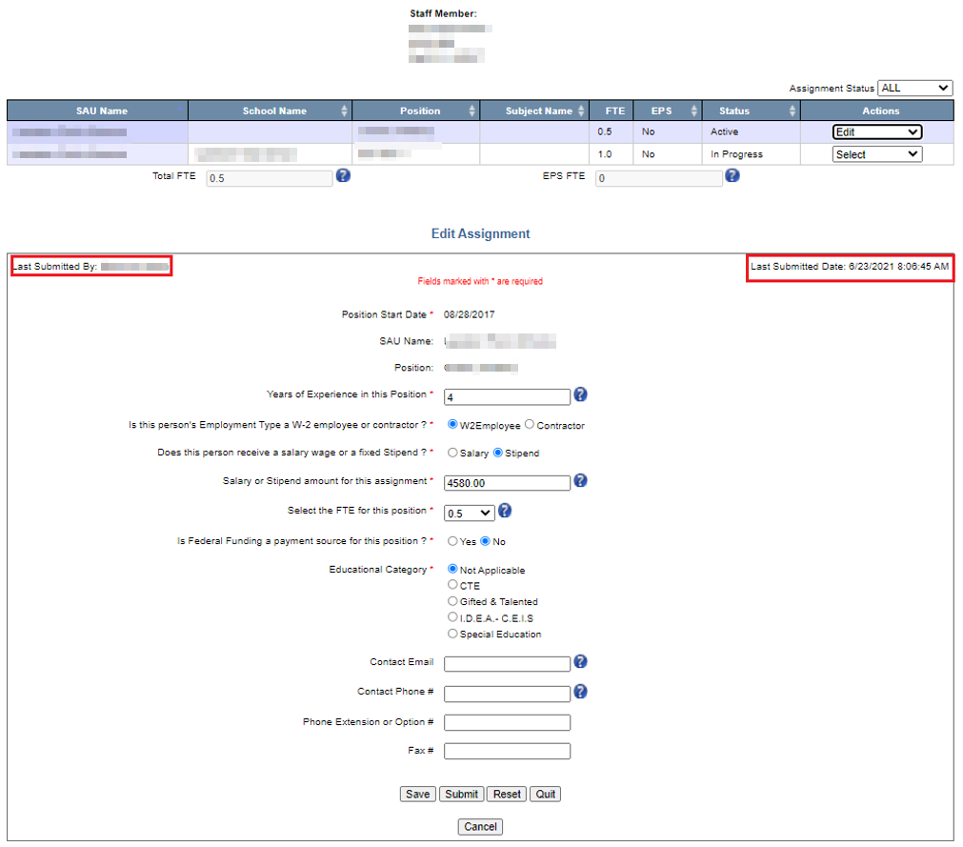
- All the other functionalities are left unchanged at this time.

Staff Certification:
- New column “Number of In Progress Position” is added to the grid.
  - User will be able to certify the district positions given that there no in progress positions.
    - If there’s at least one in progress position, the user will not able to certify the district positions and message will be displayed saying the same (refer image below for further details)
  - All the other columns are functionalities remained the same at this time.
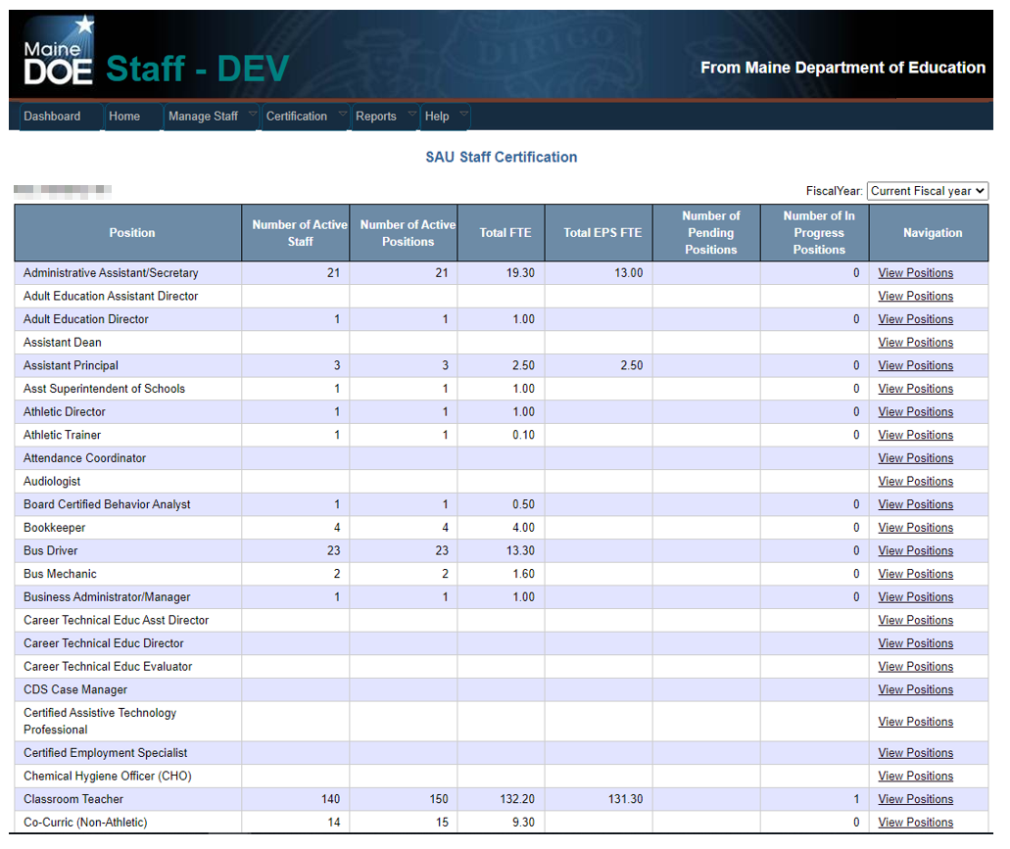
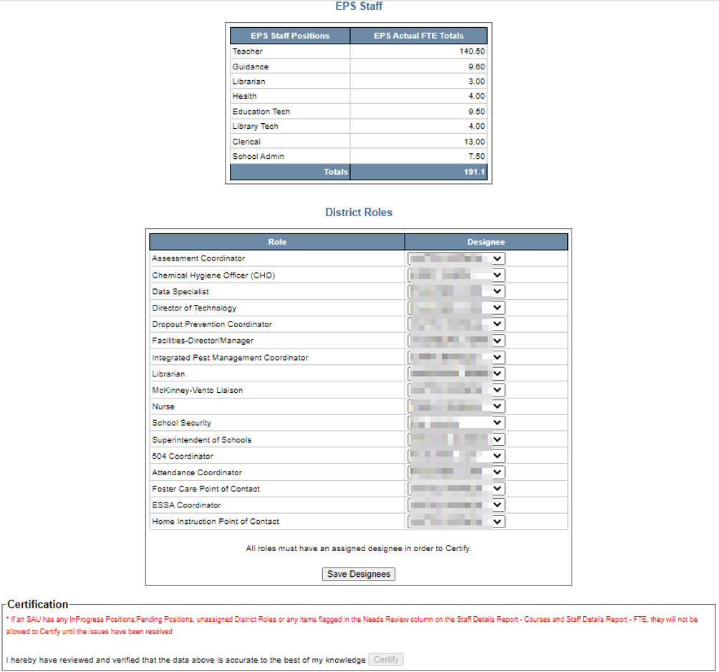

Staff Reports:
Created a new report named “Staff Details Report” which was created by merging the Staff Details Report – Courses and Staff Details Report – FTE.
