Daily Attendance Manual Entry

- In Synergy you must be focused at the school that the student is enrolled at
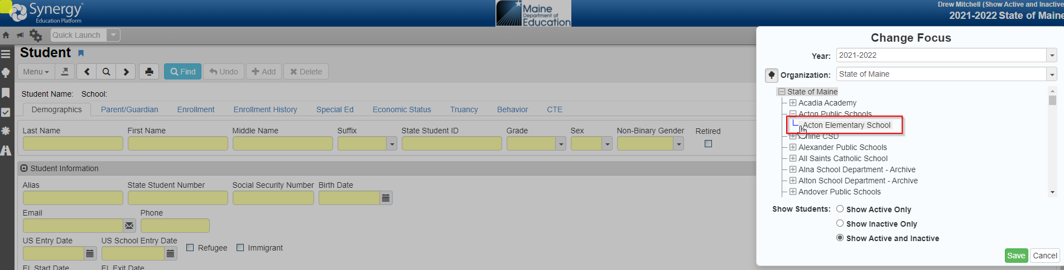
- Next go to the PAD Tree > Synergy SIS > Attendance > Student Daily Attendance
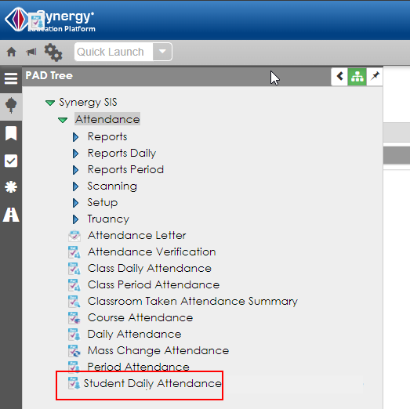

- This is the new attendance screen. You can enter in attendance at the daily level along with the modality of the attendance (Face to Face or Remote). The module will automatically show you the percentages of excused, unexcused, present, face to face, and remote.
- You click add
- Enter in the date
- Enter attendance status (Excused, Unexcused, or Present)
- Enter in the modality (Face to Face or In Person)
- Finally click save at the top (please note that you can do multiple days at once by clicking the add line for each day).
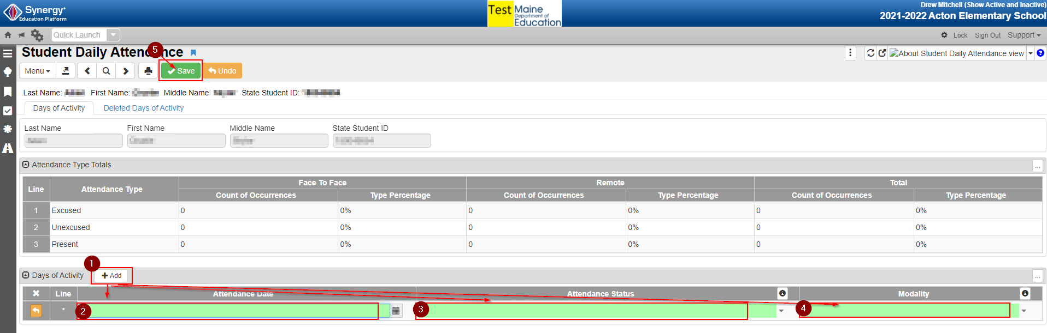
3a: Example of entering multiple days at once
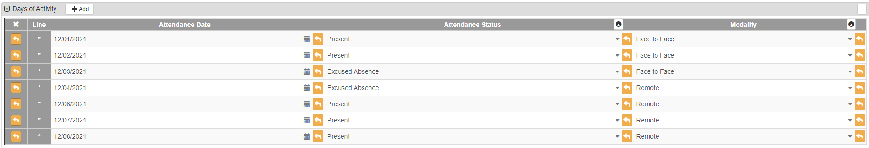
- Once you click save you will see the calculations on the attendance you have entered shown on the screen.

- If you need to make a change to entered data you can either click into the field you need to modify or delete the whole line, depending on what you need to do. Either option requires you to click save at the top of the screen for the edit to take effect.
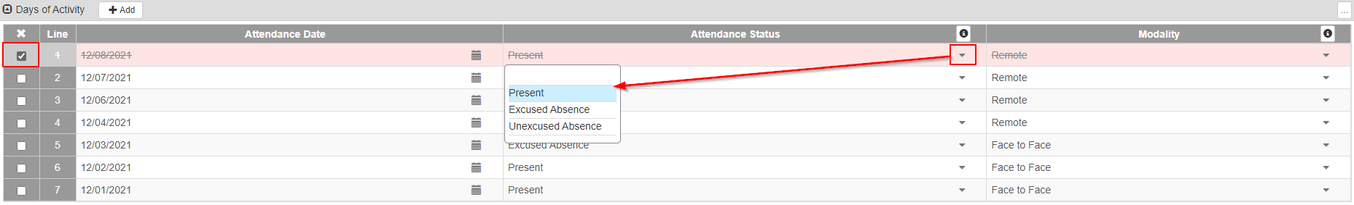

Contact for Questions
Should you have questions on what to report, when to report, or have any issues accessing Synergy State Edition, please contact the MEDMS Helpdesk or call us at 207-624-6896.

